C:\Users\RaiN OveR Me\Desktop\logo.jpg

E-Commerce Project

On

Shoe Shop

Professor: Patrik Gignac

Course Code: Comp-229

Course Title: Web Application Development

Date: December 07, 2012

|  |  |  |  |  |
| --- | --- | --- | --- | --- |
| Member | Last Name | First Name | Student Number | Section |
| 1 | Sharma | Lovu Dhiraj | 300721225 | 062 |
| 2 | Arora | Sumit | 300711055 | 062 |
| 3 | Karakkoodam Raju | Sonny | 300712674 | 062 |
| 4 | Valecha | Devraj | 300716269 | 062 |

Design:-

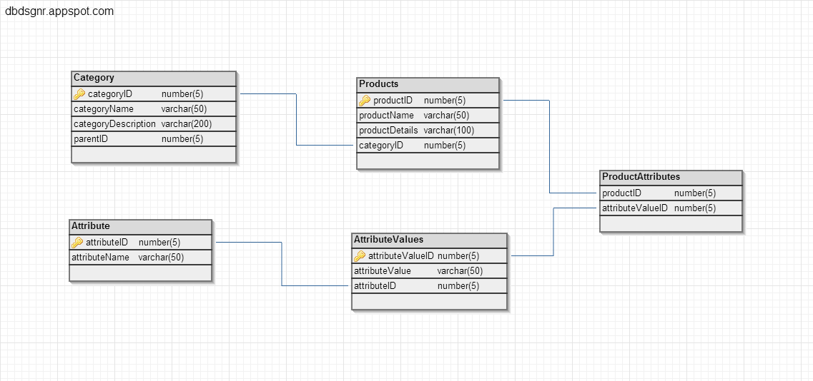

Tables and Structure:-

1. **Category:** Contains data for all the categories and sub categories of the products to be stored in the database.

|  |  |  |
| --- | --- | --- |
| **Column** | **Properties** | **Description** |
| categoryID | * Number(5) * Not Null * Primary Key | Primary key for the table |
| categoryName | * Varchar(50) * Not Null | Name of the category |
| categoryDescription | * Varchar(200) * Not Null | Description of the category |
| parented | * Number(5) * Not Null * Default 0 | ID of the parent from category table if category is sub category. |

1. **Products:** This table gives description about products and product details.

|  |  |  |
| --- | --- | --- |
| **Column** | **Properties** | **Description** |
| categoryID | * Number(5) * Not Null * Primary Key | Primary key for the table |
| categoryName | * Varchar(50) * Not Null | Name of the category |
| categoryDescription | * Varchar(200) * Not Null | Description of the category |
| parented | * Number(5) * Not Null * Default 0 | ID of the parent from category table if category is sub category. |

1. **Attribute:** This table describes the type of attribute with attributeID and attributeName.

|  |  |  |
| --- | --- | --- |
| **Column** | **Properties** | **Description** |
| categoryID | * Number(5) * Not Null * Primary Key | Primary key for the table |
| categoryName | * Varchar(50) * Not Null | Name of the category |
| categoryDescription | * Varchar(200) * Not Null | Description of the category |
| parented | * Number(5) * Not Null * Default 0 | ID of the parent from category table if category is sub category. |

1. **AttributeValues:** This table describes the values of the attribute.

|  |  |  |
| --- | --- | --- |
| **Column** | **Properties** | **Description** |
| categoryID | * Number(5) * Not Null * Primary Key | Primary key for the table |
| categoryName | * Varchar(50) * Not Null | Name of the category |
| categoryDescription | * Varchar(200) * Not Null | Description of the category |
| parented | * Number(5) * Not Null * Default 0 | ID of the parent from category table if category is sub category. |

1. **ProductAttributes:** This table describes the product attributes on products.

|  |  |  |
| --- | --- | --- |
| **Column** | **Properties** | **Description** |
| categoryID | * Number(5) * Not Null * Primary Key | Primary key for the table |
| categoryName | * Varchar(50) * Not Null | Name of the category |
| categoryDescription | * Varchar(200) * Not Null | Description of the category |
| parented | * Number(5) * Not Null * Default 0 | ID of the parent from category table if category is sub category. |

Indexes:-

|  |  |  |  |  |
| --- | --- | --- | --- | --- |
| **No.** | **Index Keyname** | **Table** | **Column** | **Description** |
| 1. | category_id_idx | category | * categoryID * parentID | Search index comprises of categoryID and parentID |
| 2. | product_id_idx | products | * productID * categoryID | Search index comprises of productID and categoryID |
| 3. | attribute_value_id_idx | attributeValues | * attributeValueID * attributeID | Search index comprises of attributeValueID and attributeID |
| 4. | product_attribute_idx | productAttributes | * productID * attributeValueID | Search index comprises of productID and attributeValueID |

StoredProcedures:-

1. **GetParentCategories**

|  |  |  |  |
| --- | --- | --- | --- |
| **No.** | **Parameter** | **IN** | **OUT** |
| 1 | cursor_categories |  | Yes |

**Explanation:**

This stored procedure retrieves the list of parent categories from the category table. The row is identified as parent category if the value of parentID column is 0.

1. **getAllCategories**

|  |  |  |  |
| --- | --- | --- | --- |
| **No.** | **Parameter** | **IN** | **OUT** |
| 1 | cursor_categories |  | Yes |

**Explanation:**

This stored procedure retrieves all the items stored in the category table.

1. **getCategoriesByID**

|  |  |  |  |
| --- | --- | --- | --- |
| **No.** | **Parameter** | **IN** | **OUT** |
| 1 | category_id | Yes |  |
| 2 | cursor_categories |  | Yes |

**Explanation:**

Category_id is id of the parent category passed into the stored procedure. The procedure retrieves all the details of the subcategory associated with the parent category.

1. **getProductsByCategoryID**

|  |  |  |  |
| --- | --- | --- | --- |
| **No.** | **Parameter** | **IN** | **OUT** |
| 1 | category_id | Yes |  |
| 2 | cursor_products |  | Yes |

**Explanation:**

This store procedure returns all product list from the Products table, which are under the category passed in.

1. **getAttributesByProductID**

|  |  |  |  |
| --- | --- | --- | --- |
| **No.** | **Parameter** | **IN** | **OUT** |
| 1 | product_id | Yes |  |
| 2 | cursor_products |  | Yes |

**Explanation:**

This stored procedure returns the list of attributes available to the product whose product_id is passed in.

Functions:-

1. **getCountOfProductsByCategoryID**

|  |  |  |  |
| --- | --- | --- | --- |
| **No.** | **Variable** | **Type** | **DataType** |
| 1 | category_id | Parameter | Number |
| 2 | total_count | Variable | Number(5) |

**Explanation:**

This function calculates the number of products available in the category, whose value is passed it. The count is stored in the variable total_count and is returned

1. **getCountProAttrByID**

|  |  |  |  |
| --- | --- | --- | --- |
| **No.** | **Variable** | **Type** | **DataType** |
| 1 | attribute_id | Parameter | Number |
| 2 | total_count | Variable | Number(5) |

**Explanation:**

Triggers:-